Part 1:

Testing SpellCheck with the provided data files:

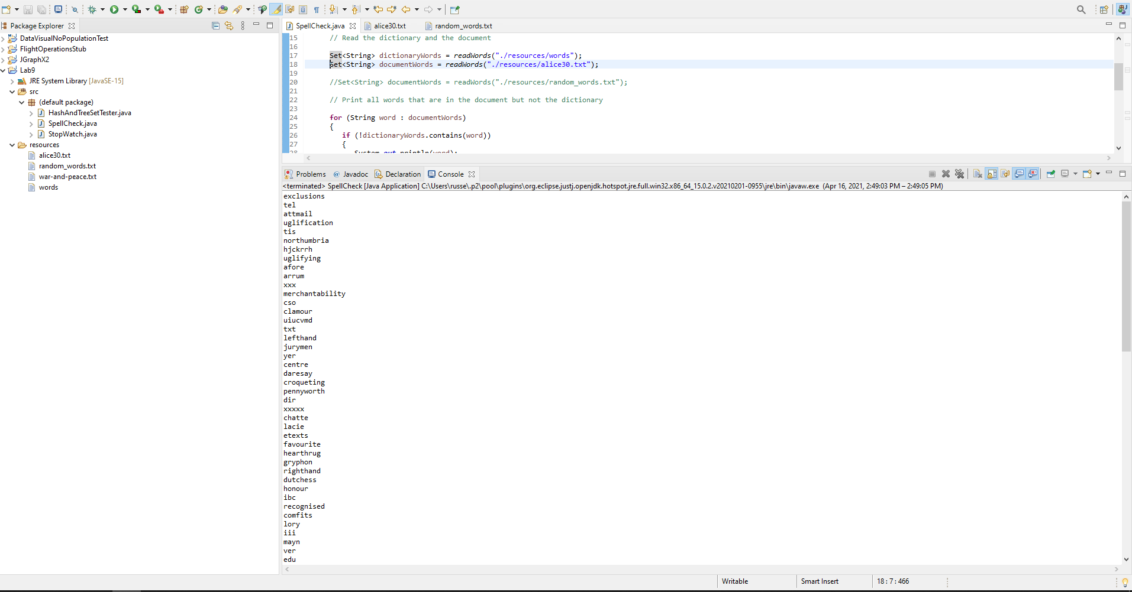

Testing SpellCheck with my random_words.txt file

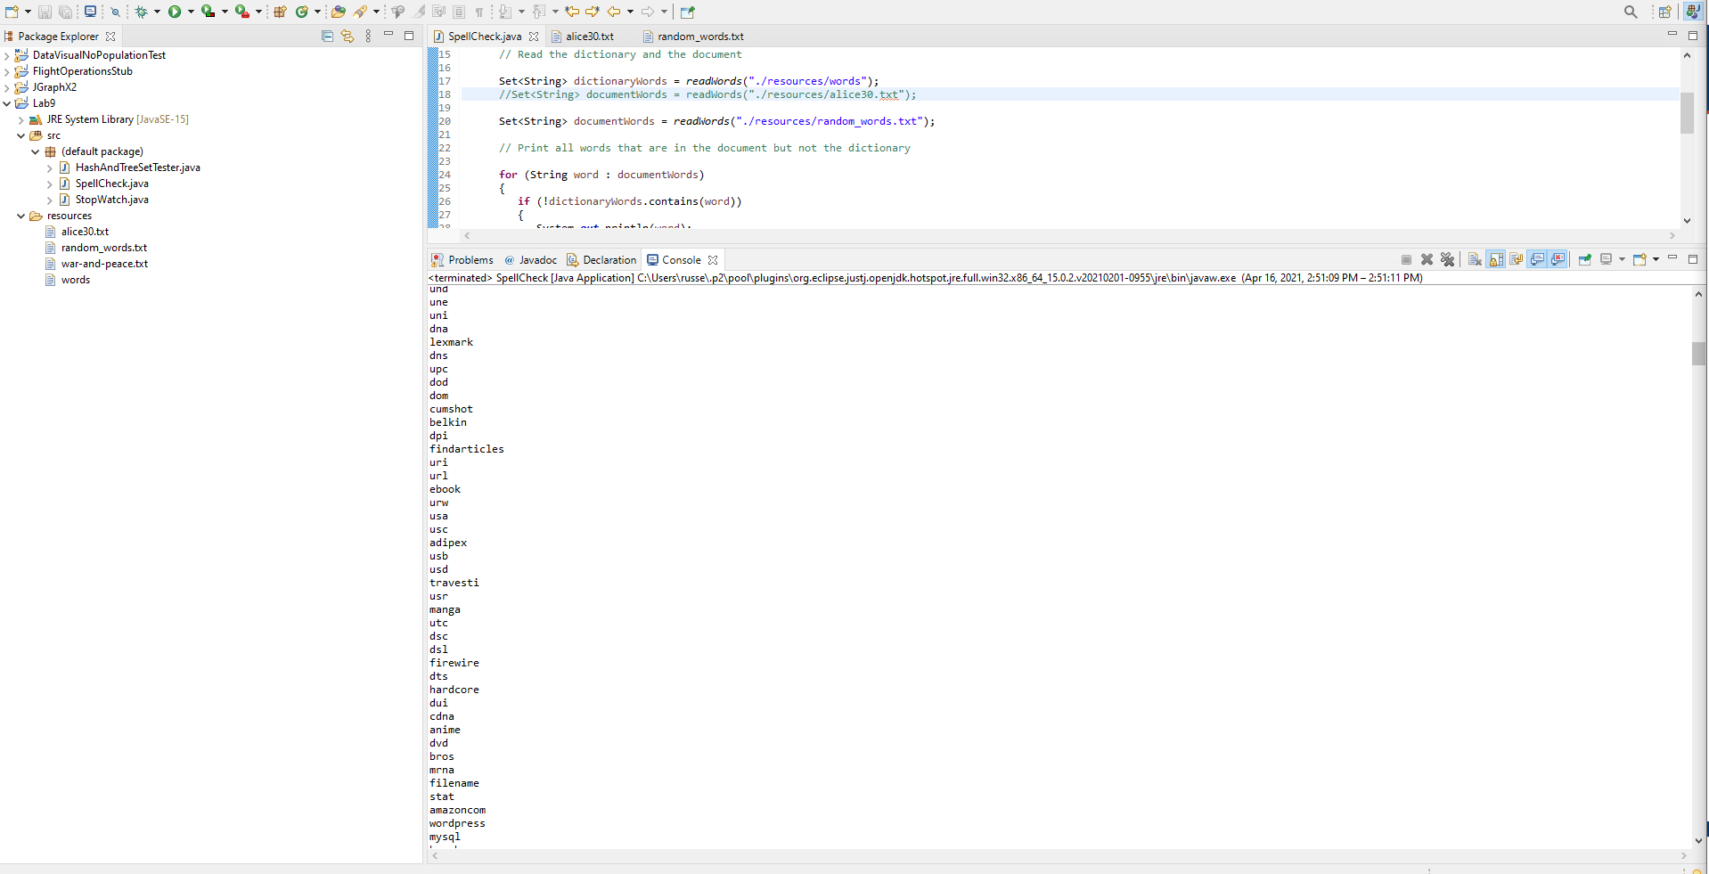

Part 2:

Starting Read HashSet Test for ArrayList

Elapsed time for hashset 404 milliseconds. Number of words: 565454

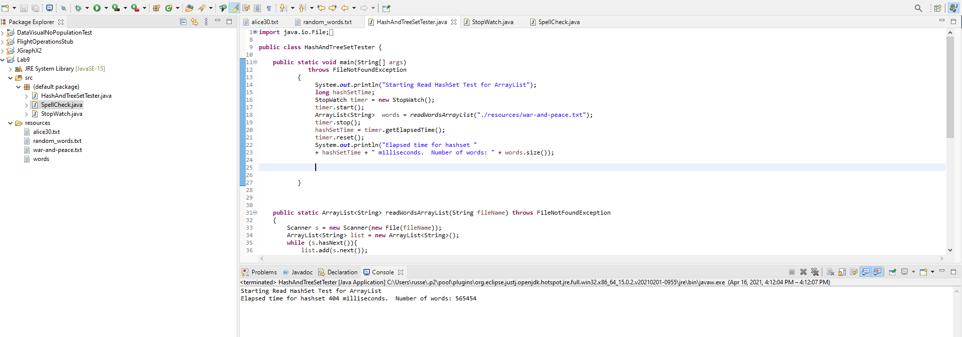

Starting Read HashSet Test for TreeSet

Elapsed time for hashset 468 milliseconds. Number of words: 41967

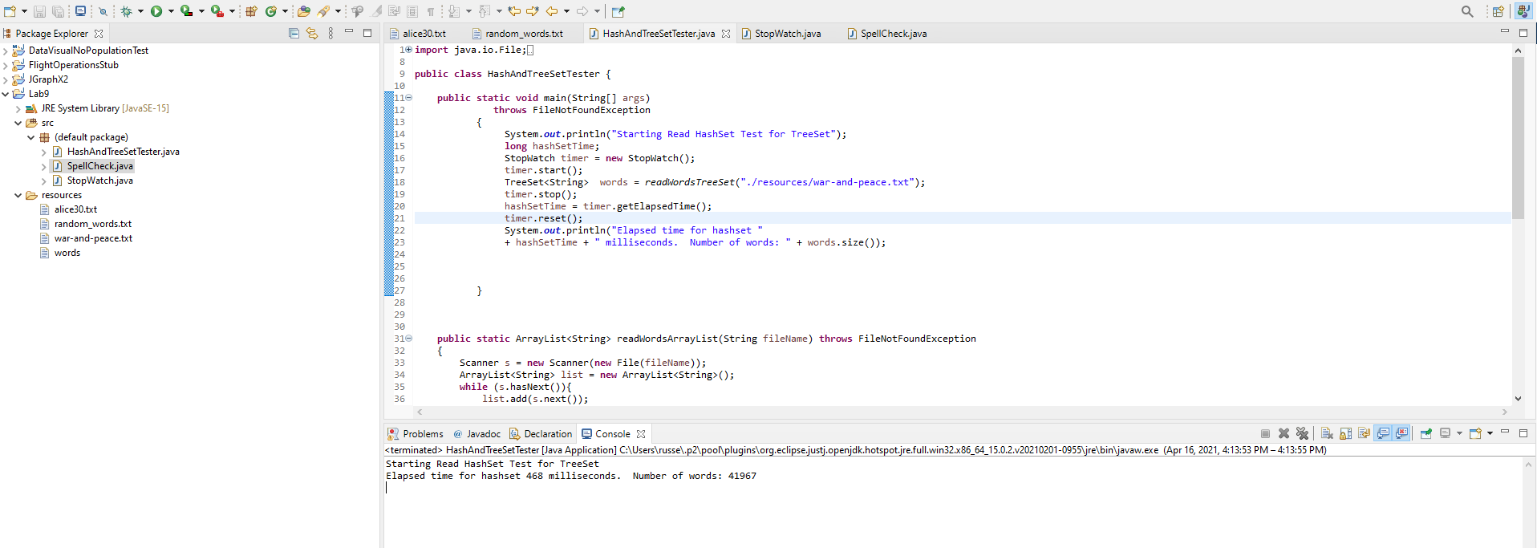

Starting Read HashSet Test for TreeSet

Elapsed time for hashset 414 milliseconds. Number of words: 17624

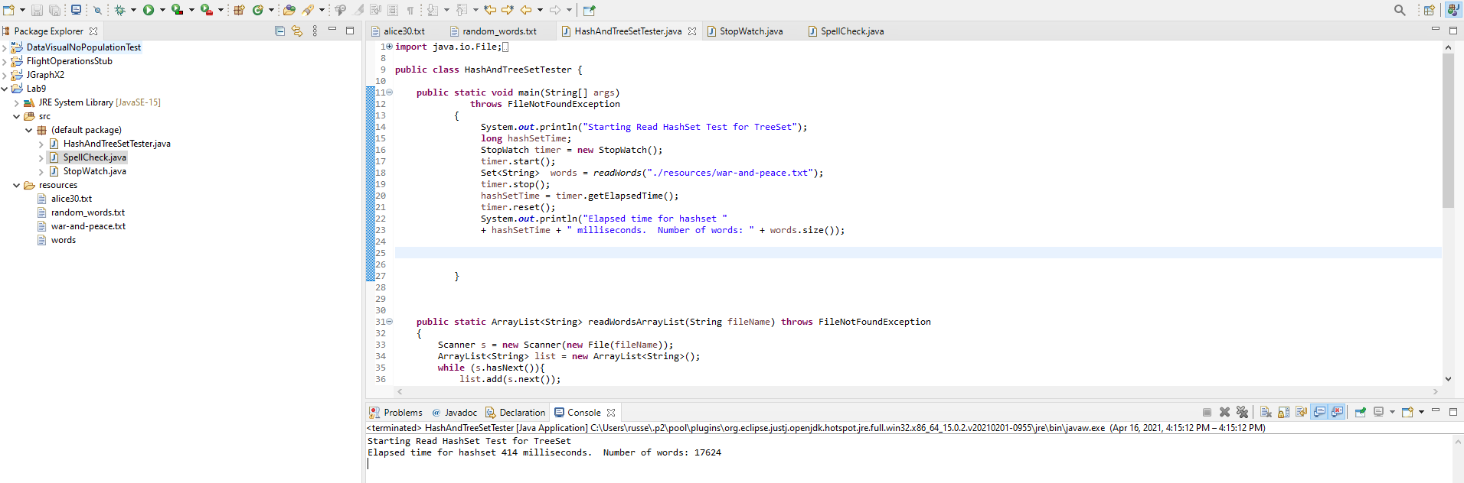

HashSets and TreeSets - Performance

* HashSet offers constant time cost while TreeSet offers log(n) time cost for such operations.  Review the meaning of these Big O performance metrics and which was is faster?
  + The result shows that the HashSet provides faster lookup for the element than the List. This is because of no duplicate data in the HashSet. The HashSet maintains the Hash for each item in it and arranges these in separate buckets containing hash for each character of item stored in HashSet.